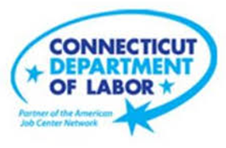

**NEW WEEKLY JOB POSTINGS FROM   
HELP WANTED ONLINE  
Office of Research**

**Week Ending November 5th, 2022: Manufacturing Job Ads Drive Over The Week Increase**WETHERSFIELD, November 10th, 2022 – During the week ending November 5th, there were 7,550 new postings, up 216 new ads or +3% over the week. 10 industries had over the week increases and 11 had decreases. Manufacturing had the largest increase, up 115 new ads (+17%) and Educational Services had the largest decrease, down 65 new ads   
(-17%). Within Manufacturing, the employers with the largest new ad increases were Boehringer Ingelheim (+70 new ads) and Eaton (+48 new ads). The graph below shows top line counts for Connecticut and the US, the US was up 4% over the week. Adjacent states of New York, Massachusetts, and Rhode Island had over the week shifts of   
-5%, -3%, and +1% respectively. Note: The Help Wanted Online data series was revised last month to better reflect job posting behavior on some of its source job board websites. This revision resulted in lower total counts for May-August 2022.  
  
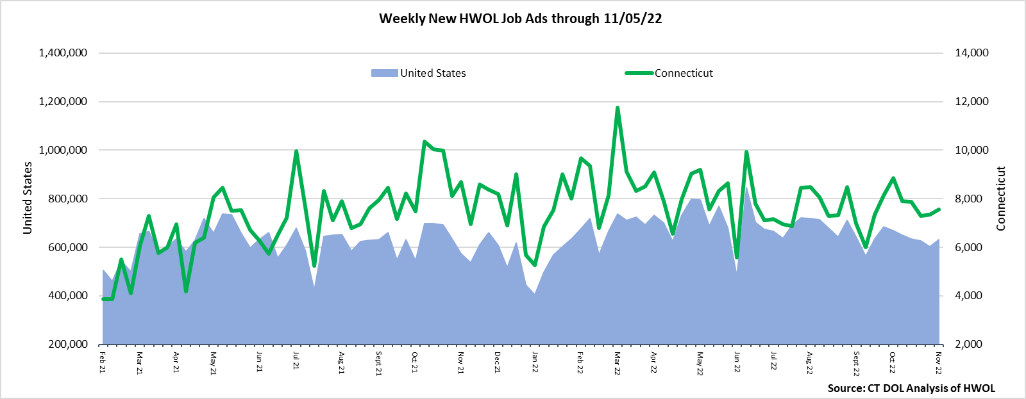  
**Industries** with the most new postings include Health Care & Social Assistance, Manufacturing, and Finance & Insurance.

**Occupations** with the most new postings include Registered Nurses, Retail Salespersons, and Supervisors of Retail Sales Workers.

**Employers** with the most new postings include Yale-New Haven Health System, Hartford Healthcare, and Community Health Center, Inc.

**The three industries with the most new job postings were:**

* **Health Care & Social Assistance** (1,540 new postings, +7% over the week)
* **Manufacturing** (809 new postings, +17% over the week)
* **Finance & Insurance** (761 new postings, +15% over the week)

   
 During the week ending November 5th, 2022, the 3% new ad total increase is the net result of increases in 10 industries and declines in 11. The 10 increasing industries grew by a combined 429 new ads and most of that increase occurred in Manufacturing (+115 new ads) and Finance & Insurance (+97 new ads). The decreasing industries fell by a combined 213 new ads with most of that occurring in Educational Services (-65 new ads) and Arts, Entertainment, & Recreation (-41 new ads). Over four weeks, new ads were down 4% or -317 new ads. 12 industries were down and 9 were up. Large four-week declines occurred in Retail Trade (-143 new ads) and Accommodation & Food Services (-67 new ads). The 9 industries with four-week increases grew by a combined 252 new ads. Manufacturing (+115 new ads) had the largest four-week increase.  
  
 For more information on total job ads by industry for Connecticut and its labor market areas, see the monthly report available here: <https://www1.ctdol.state.ct.us/lmi/hwol.asp>

**New Job Postings by Occupation** 

**The occupations with the most new postings were:**

* Registered Nurses (317 new postings, -12% over the week)
* Retail Salespersons (270 new postings, +1% over the week)
* Supervisors of Retail Sales Workers (192 new postings, +28% over the week)

**Employers with the Most New Job Postings**  Employers with the most new job postings during the week were mostly in Healthcare & Social Assistance, Finance & Insurance and Retail Trade. The 25 employers shown above account for 19 percent of all new ads. 15 of 25 employers in the top 25 had over-the-week increases, one was unchanged, and 9 had decreases. The top 25 employers with the largest over the week increase and decrease were ATX Learning (+79 new ads) and the State of Connecticut and Community Health Center Inc., both down 35 new ads.   
  
**What is HWOL?**The **Conference Board Help Wanted Online**® Data Series (HWOL) measures the number of new, first-time Online job postings and jobs reposted from the previous month for over 16,000 Internet job boards, corporate boards, and smaller job sites that serve niche markets and smaller geographic areas. To view more HWOL data, go to: <https://www1.ctdol.state.ct.us/lmi/hwol.asp>